AGM Minutes 2021
Attendances
Robert Cockerill
Anthony Cross
Nicky Percy
Trevor Bell
Paul Whitehouse
Kat Platt
Michael Banks
Julie Burrows
Stuart Smerdon
Fred Barnes

Apologies
Carole Booth
Amit Mistry
Sarah Coulas
Jon Jackson

AGM Minutes 2019
Proposed – Michael Banks
Seconded – Julie Burrows
All accepted

Officer Reports
Treasurer
Report Enclosed – David Beck thanked as independent auditor
Fees at £7 per person.
Proposer – Nicky Percy
Seconder – Julie Burrows
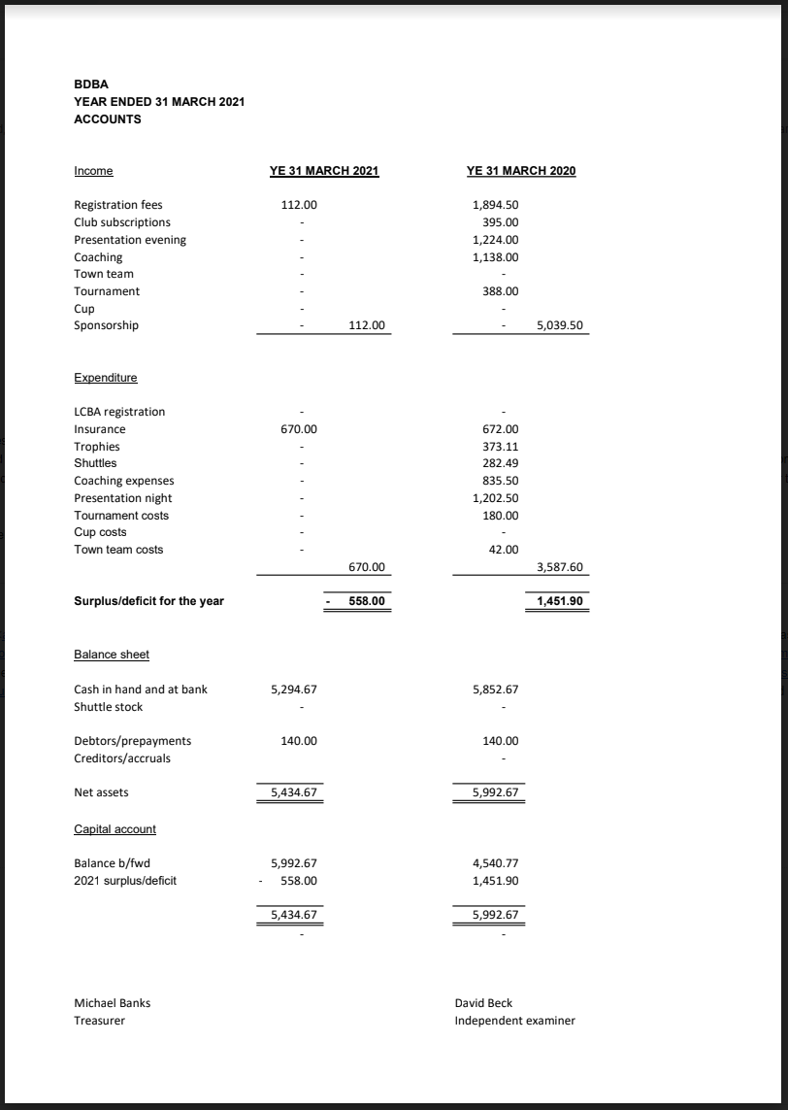

Match Secretary
2019/ 2020 Season

Division 1:
Winners Fleetwood A continue their record consecutive run however, this will be the last time the Fleetwood name will be on a trophy on its own, as Fleetwood & Hesketh have merged to become Hesketh/ Fleetwood. Poulton were valiant runners up.

Division 2
Congratulations to Pilling B however, this team has been dropped for the forthcoming season! Albany B were runners up and, this season have merged with Warton to become Lightning.

Division 3
Congratulations to Stanley. Lids B were runners up but, this team has also been dropped for the forthcoming season

Levels:
Congratulations to Warton however, as already mention they have merged to become Lightning. Runner up Fleetwood (see above).

Sadly, the Cup competitions had to be scrapped after the first round due to Covid Pndemic.

Thanks to Brian for the match write ups, they are very much enjoyed.

2020/ 2021 season - Not held due to Covid Pandemic.

2021/ 2022 Season;

Mixed teams now down to 15 teams I was thinking about 3 small leagues but, some teams have dropped out in the last 2 weeks so, there would be a danger of a very small league therefore, there will be two divisions of 7 (Division 1) and 8 (Division 2). Levels down to 6 teams and, sadly Broughton have left the BDBA but, I hope they rejoin us in the future.

Just waiting on details from one club before I am able to finalise the fixtures.

Anthony Cross
(League match Secretary)

Cup Matches - all rounds to be played at Preesall.

Chairmans Report
None to report, but I will be leaving the position at the end of this year with a new chair in place at the end of this season.

Proposals

Proposal 1
Mens and Womens singles to be added to the league format
For 1 Against 13 Abstain 1

Proposal not carried.

Proposal 2
Doubles ladder, running all year, winners on points after 6 months, 3 x games (no setting – first to
21).
Mini league of 4 doubles pairings, men, women or mixed. Players could appear in a levels and a
mixed pairing. Each pair play their 3 opponents within a month, league adjusted at each month end.
I feel this would make best use of the RPS system and may encourage new or returning players.

Discussion had and decision to continue with levels league and run this alongside with Paul Whitehouse to look to run under the Blackpool league.

Proposal 3
Club night – all agreed but needs someone to run the night

Proposal 4
Use of Hybrid Shuttles – allowed within the current rules.

Proposal 5
I would like to propose that an extra player be allowed to play in the Mixed league i.e. that one man or lady could play doubles only and another player could play the mixed. As we are all getting older, some players may still want to be involved but 8 games is too much for them. Also, it would mean perhaps if someone is injured in the doubles, a reserve could take their place in the mixed.

For 6 Against 9 Proposal not carried
Election of officers
Chair – Robert Cockeril - Nicky Propose Paul Second
Vice Chair – Trevor Bell – Rob Propose Michael Second
Match Secretary – Ant Cross – Michael Paul Second
Secretary – Nicky Percy – Michael propose, Kat Second
Treasurer – Michael Banks – Rob propose Ant Second
Press and Publicity – Brian Oakes Nicky second Kat
Tournament - None
Social Secretary - None
Council Members – Jon Jackson, Paul Whitehouse, Sarah Coultas, Kat Platt, Steve Blackburn all current members

